**TAI**

* **Project brief:**

TAI food sharing website.

TAI will be the first Arabic food-sharing website. TAI connects people and allows them to share the food excess so the surplus food and other items won’t be a waste and thrown away. Our main goal is to reduce food waste.

* **Social impact:**TAI aims to help create a world in which nothing of value goes to waste, and every single person has enough to eat – without destroying our planet in the process.
* **Use Case Diagram:**

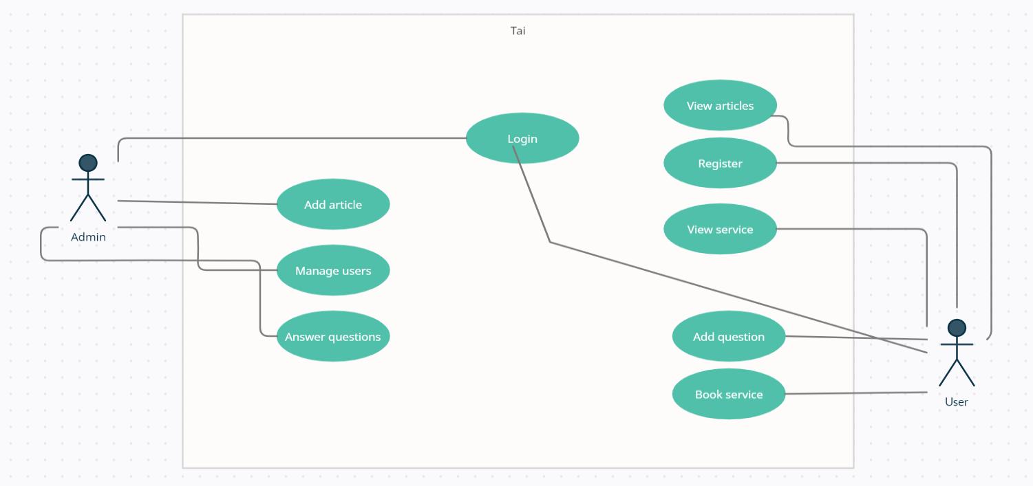

The website have two users types:

1. The user is anyone who visits the website to order services, see articles and add services, will have access to the **LANDING , REGISTER & LOGIN, SERVICES, ADD SERVICE and CONTACT US** Pages.
2. The admin of the website can add articles, manage users and answer questions from his dashboard.

**The website pages:**

**Landing Page:  
  
Services:**

Includes all the services on the website which anyone can order from.  
  
**Add Services:**

The user can add service to the website through this page.  
  
**Articles:**

Will include articles related to the website, its services, and how to contribute.  
  
**Contact Us:**

A form so the user can fill a message, it will be directly sent to the website admin email.

* **Database Schema:**

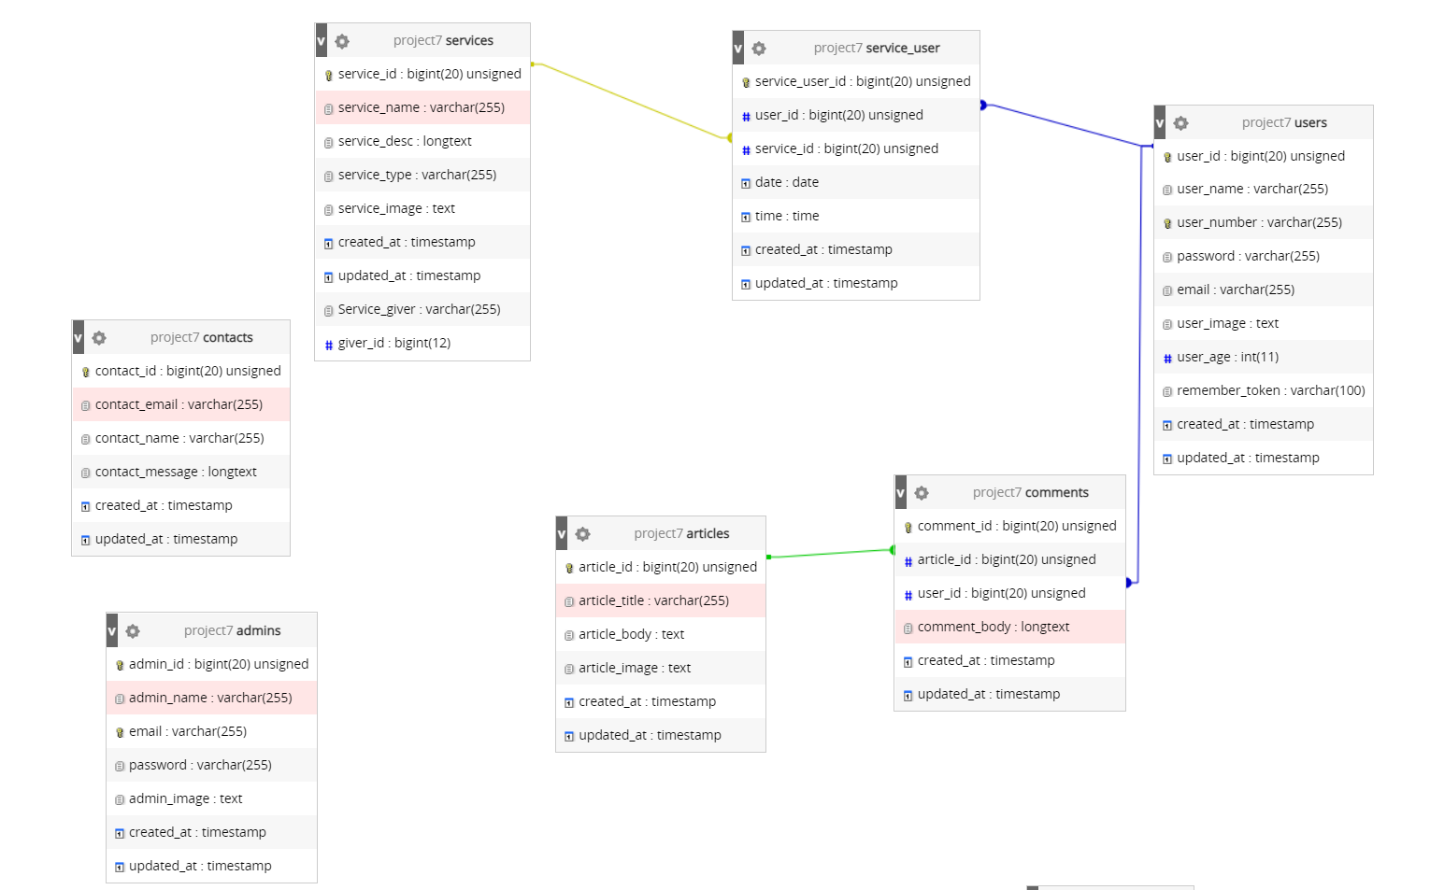

Relationships:  
User has one to many relationship with comments and service user (bought service)

Article has one to many relationship with comments  
  
Service has one to one relationship with service user

* **Used Technologies:**1-Front End:

1-Front End:

• HTML (HyperText Markup Language) as a building block of the Website.

• CSS to describe the style of an HTML document.

• Bootstrap 4 is a toolkit for developing with HTML, CSS, and JS

• JavaScript (JS) is a lightweight, interpreted, or just-in-time compiled programming language with first-class functions.

2-Back End:

• PHP is a popular general-purpose scripting language that is especially suited to the web.

• XAMPP is an Apache distribution containing PHP.

• Laravel, an open-source PHP web framework, is used for its high-security features.

• MySQL open-source relational database management system (RDBMS).

* **Future Work:**  
  1-Add GPS to track the route and location of the user transportation to make it safer   
  2-Alert users of new added items nearby based on their location  
  3-Make mobile app (not priority because the website is mobile friendly)  
  4-Make chat system and public profiles.  
  5-Multi language
* **Security :**  
  The website was built with LARAVEL framework which includes built-in authentication and session services. These features provide cookie based authentication for requests that are initiated from web browsers. They provide methods that allow you to verify a user's credentials and authenticate the user.  
    
  **Test cases**  
  Form validation when the user is under 18 years old or he entered wrong info.  
  When user enter authenticated page without privileges it will redirect him to login page  
  When user try to visit wrong link address it will show him a 404 page
* **Conclusion:**  
  As an obstacle It was insane to make the perfect food sharing website with full futures, So i tried my best to develop an MVP Website that i can continue to work on and add extra stuff in the future.
* **Mockup:**

**The sign in page:**

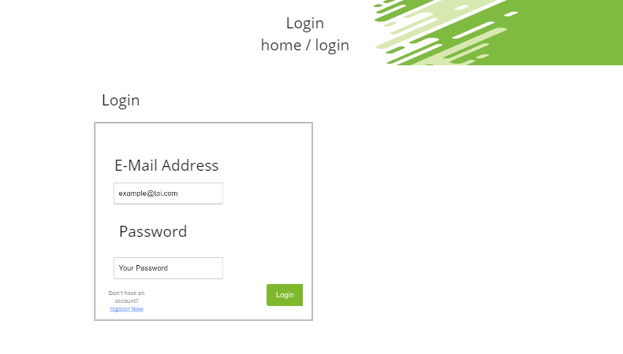

**Register page:**

**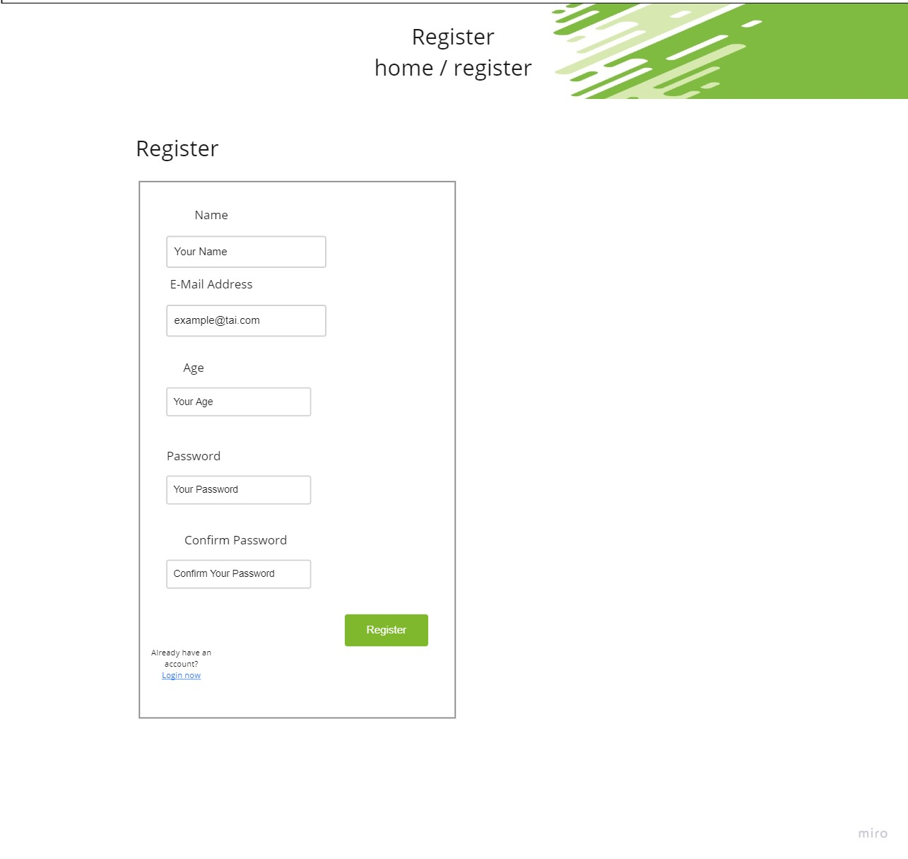  
  
  
  
  
  
  
  
  
  
  
  
  
  
  
  
  
  
  
LANDING PAGE:**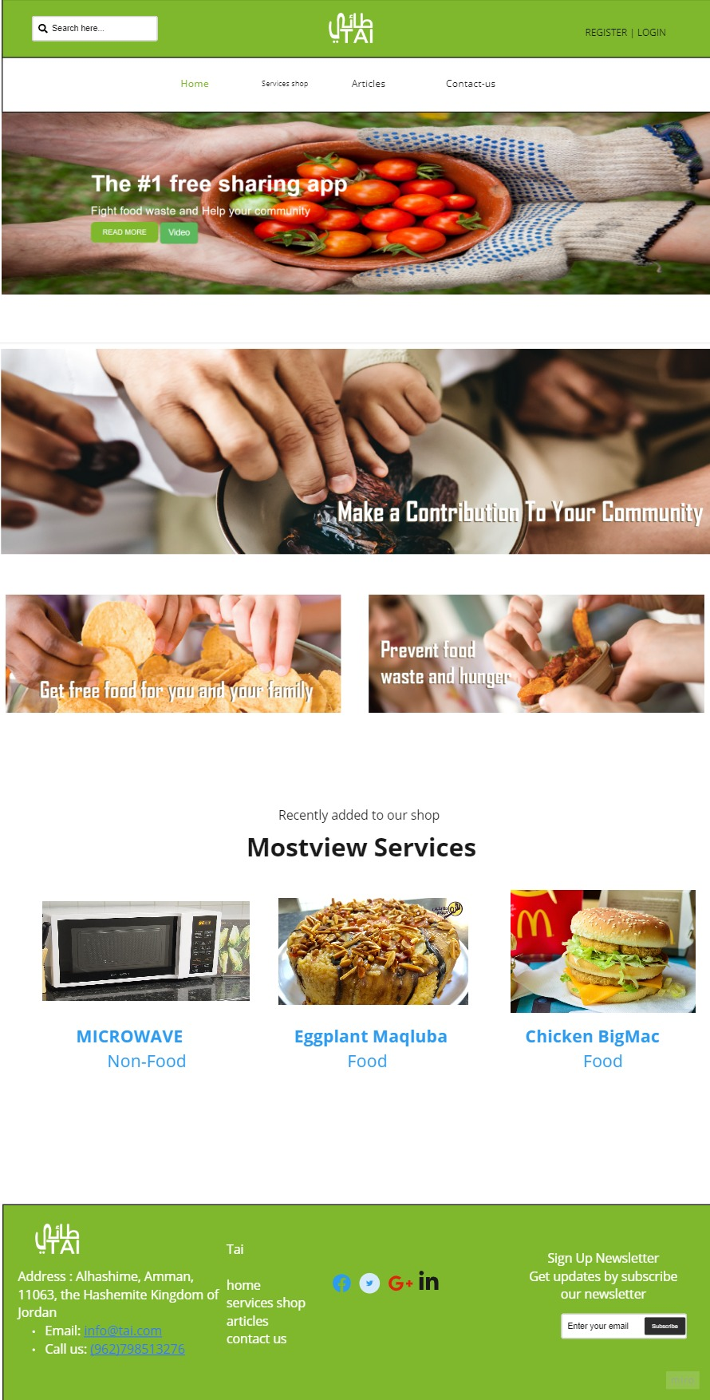

**Services shop page:**

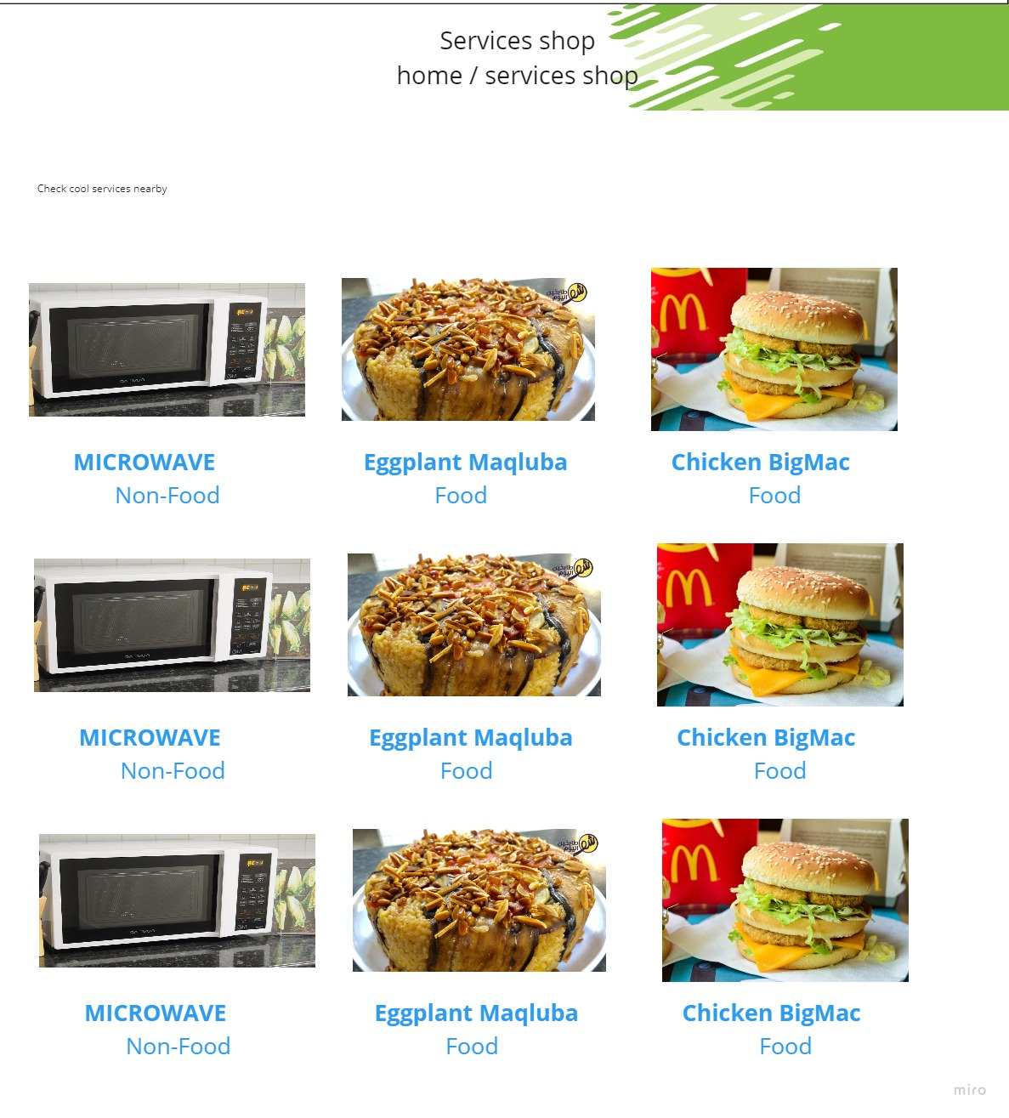  
Single service page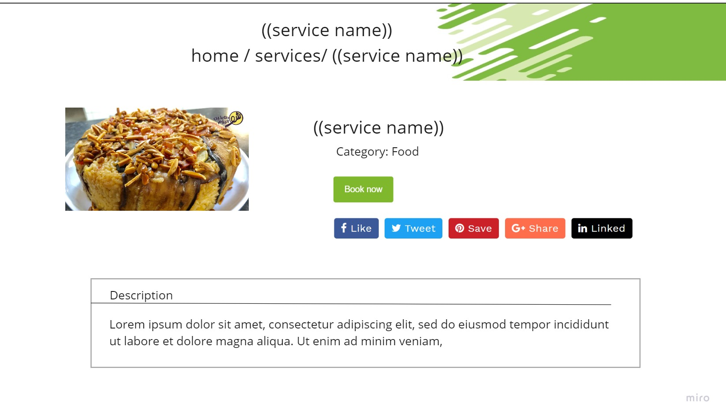Add service page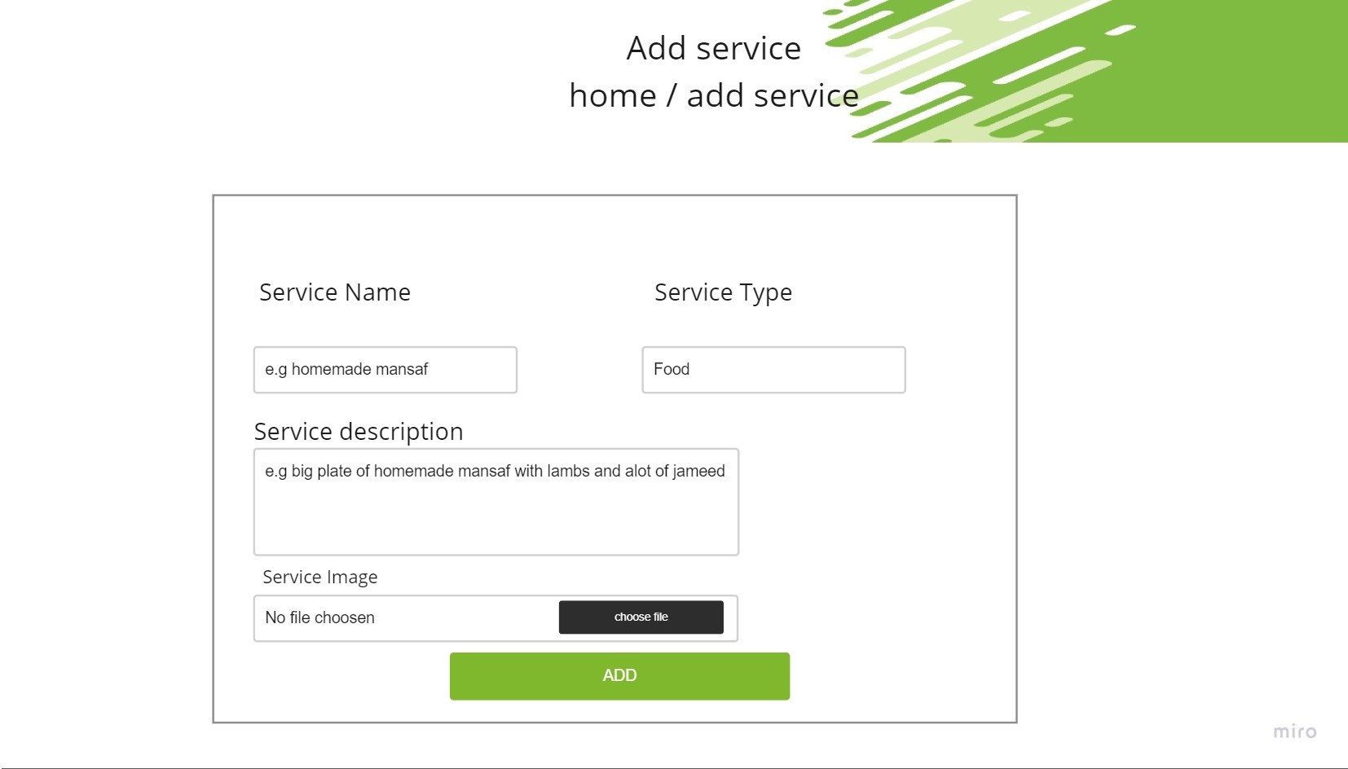  
  
Articles page 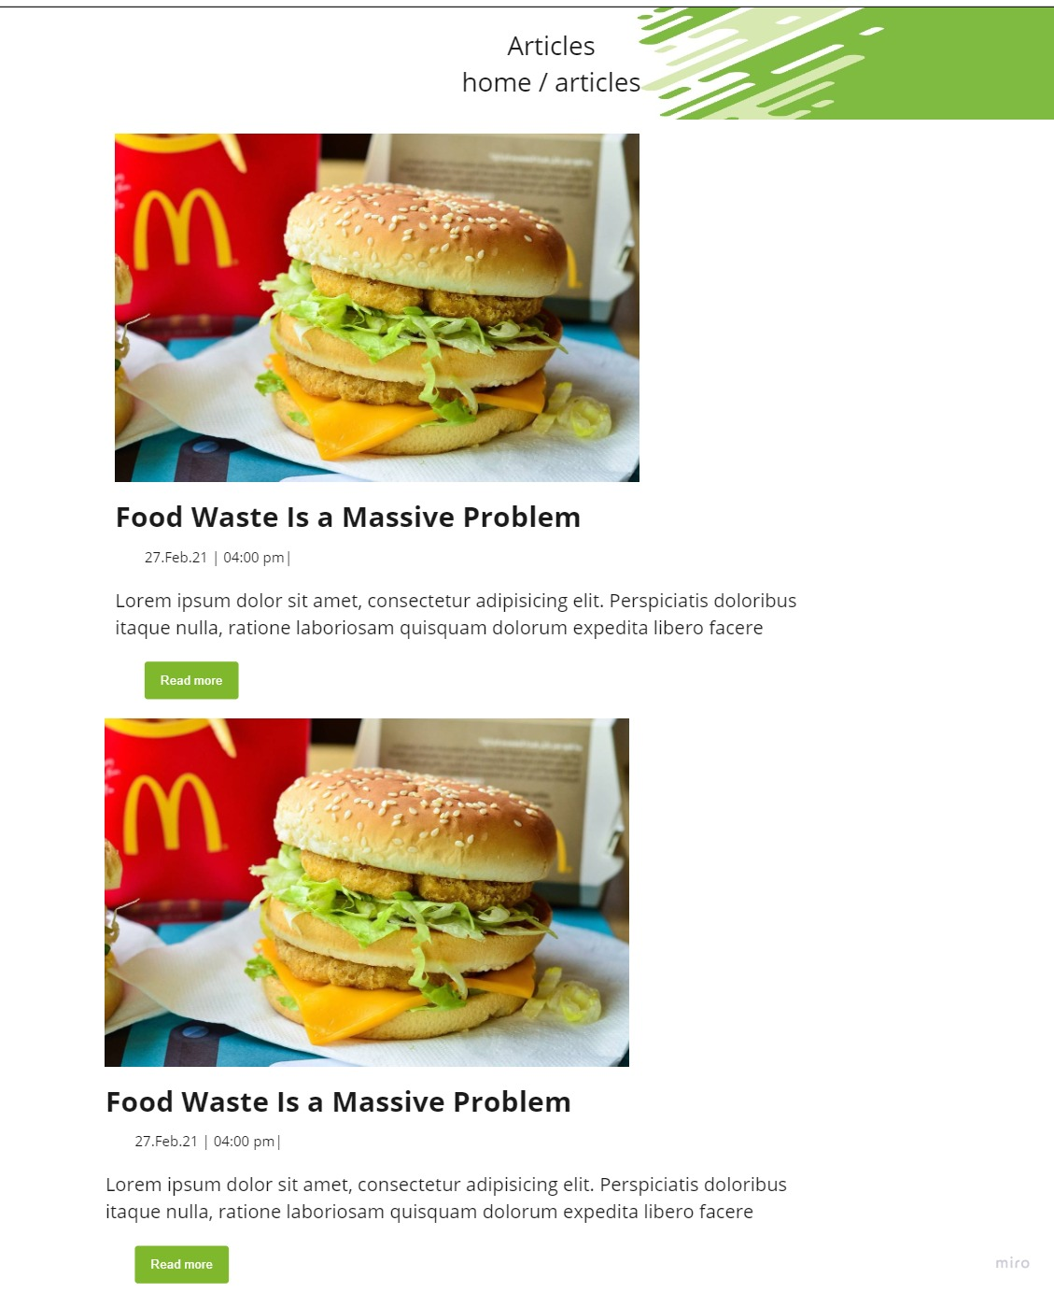  
Single article page 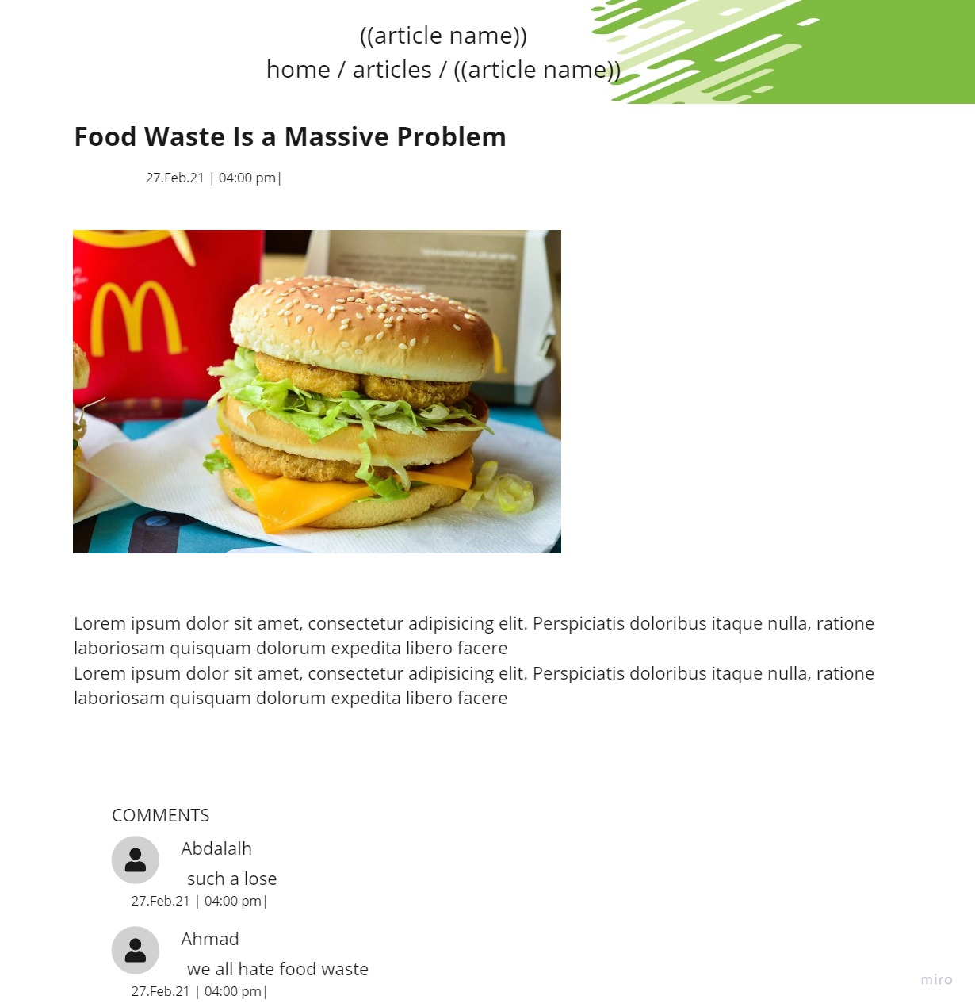  
Contact us 